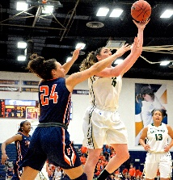 | Men’s AAU  Coach Role, Varsity Boys  Coach Gallo, Coach Davis, MS Boys

Athlete Information

Applicant Information
Full Name: |  |  |  | Date:
 | Last | First | M.I.

Address:
 | Street Address | Age/Grade

 | City | State | ZIP Code

Phone: |  | Email

Parent Information
Father: |  | Address:

Phone: |  | Email:

Mother: |  | Address:

Phone: |  | Email:

Goals for Athlete
Please list three main areas in need of work.
First Area:
Second Area:
Third Area:

Participation

Every participant must have a signed medical release waiver included with this form. Medical release waiver will be sent with this form.

Please return participation form and medical release to rrole42@gmail.com or pahpbasketball@gmail.com

